CENTRAL MODEL SCHOOL
BARRACKPORE



AISSCE-CBSE
SESSION 2024-25

NAME: SUDHANSU TUDU
CLASS : XII SCI D
BOARD ROLL NO :
SUBJECT: BOARD COMPUTER PROJECT

ACKOWLEDGEMENT

I would like to take this opportunity to express my gratitude to my Computer Science Teacher Mr. Dibakar Das for providing valuable, guidance and suggestion throughout the course of the project. I owe my regards to our respected principal-in-charge Mr. Sanjay Dubey for providing me with this opportunity. I would also like to thank to my parents and my friends, whose aid was instrumental in helping me accomplish my task. This project also helped me learn and evaluate many things.

____________________
Signature of the Student

CERTIFICATE

This is to certify that the Computer Science Project on the Topic “Hotel Management System” is Submitted by Sudhansu Tudu of XII SCI D under the guidance and supervision of Mr. Dibakar Das.
This project has not been submitted to any other Institution.

Signature of the Teacher: _____________.

Signature of the External: _____________.

HOTEL
MANAGEMENT
SYSTEM

CONTENT

- Introduction of The Project.
- Project Description.
- System Requirements.
- Source Code.
- Program Output.
- Bibliography.

INTRODUCTION

A Hotel Management System is a software solution designed to streamline and automate the various operations within a hotel management. It integrates key functions such as reservation, front desk operations, guest-check-in and check-out, billing, housekeeping, and reporting to a centralized platform. HMS enhances both the guest experience and the overall management of the hotel resources. Modern system includes operations like online booking, payment gateways, customer relationship management (CRM), and analytics tools, helping managers to optimize operations customer cost, reduce cost and increase customer satisfaction.

This project is done by Python Programming and MYSQL. The database contains five tables. First tables contain booking records, storing all booking details. Second tables contain customer records such as customer details such as Name, Age, Country, Contact Info. A person can book a hotel room by providing their details, firstly room at different prices along with all facilities will be shown. The Customer can book room according their needs. After completion of booking, they will get a Booking Id with which all their booking details will be linked. Customer details can be checked using the Booking Id. Using the Hotel Management System customer details can be checked and verified.

PROJECT DESCRIPTION

This Project Consist of these Functionalities:

1. Booking Record: Booking Records can be created.
2. View Records: Booking Records can be seen.
3. Records Cancellation: Booking records can be cancelled.
4. Adding Record: New Booking record can be added.
5. Deleting Record: Existing Record can be deleted.
6. Record Update: Existing record can be updated.
7. Total Bill: Total Bill can be created or old bill can be retrieved.

SYSTEM REQUIREMENTS

Hardware:
Processor – Intel Core i3 10100 (3.6 GHz)
Ram – 16 GB
Graphics – Intel UHD 630

Software:
Operation System – Window 10 Pro
Programming Language – Python 3.13.0
Database Software – MYSQL Community Server 8.0.40

SOURCE CODE

#***************CENTRAL MODEL SCHOOL BARACKPORE **********************
#***************HOTEL MANAGEMENT SYSTEM **************************
################## CROWN PLAZA MIAMI #############################

import mysql.connector

# GLOBAL VARIABLES DECLARATION
myConnection = ""
cursor = ""
userName = ""
password = ""
roomrent = 0
restaurentbill = 0
gamingbill = 0
fashionbill = 0
totalAmount = 0
cid = ""

# MODULE TO CHECK MYSQL CONNECTIVITY
def MYSQLconnectionCheck():
global myConnection
global userName
global password
userName = input("\n ENTER MYSQL SERVER'S USERNAME : ")
password = input("\n ENTER MYSQL SERVER'S PASSWORD : ")
myConnection = mysql.connector.connect(host="localhost", user=userName, passwd=password, auth_plugin='mysql_native_password')
if myConnection:
print("\n CONGRATULATIONS ! YOUR MYSQL CONNECTION HAS BEEN ESTABLISHED !")
cursor = myConnection.cursor()
cursor.execute("CREATE DATABASE IF NOT EXISTS HMS")
myConnection.commit()
cursor.close()
return myConnection
else:
print("\nERROR ESTABLISHING MYSQL CONNECTION CHECK USERNAME AND PASSWORD !")

# MODULE TO ESTABLISH MYSQL CONNECTION
def MYSQLconnection():
global userName
global password
global myConnection
global cid
myConnection = mysql.connector.connect(host="localhost", user=userName, passwd=password, database="HMS", auth_plugin='mysql_native_password')
if myConnection:
return myConnection
else:
print("\nERROR ESTABLISHING MYSQL CONNECTION !")
myConnection.close()

def userEntry():
global cid
if myConnection:
cursor = myConnection.cursor()
createTable = """CREATE TABLE IF NOT EXISTS C_DETAILS(CID VARCHAR(20), C_NAME VARCHAR(30), C_ADDRESS VARCHAR(30), C_AGE VARCHAR(30), C_COUNTRY VARCHAR(30), P_NO VARCHAR(30), C_EMAIL VARCHAR(30))"""
cursor.execute(createTable)
cid = input("Enter Customer Identification Number : ")
name = input("Enter Customer Name : ")
address = input("Enter Customer Address : ")
age = input("Enter Customer Age : ")
nationality = input("Enter Customer Country : ")
phoneno = input("Enter Customer Contact Number : ")
email = input("Enter Customer Email : ")
sql = "INSERT INTO C_Details VALUES(%s, %s, %s, %s, %s, %s, %s)"
values = (cid, name, address, age, nationality, phoneno, email)
cursor.execute(sql, values)
myConnection.commit()
print("\nNew Customer Entered In The System Successfully !")
cursor.close()
else:
print("\nERROR ESTABLISHING MYSQL CONNECTION !")

def bookingRecord():
global cid
customer = searchCustomer()
if customer:
if myConnection:
cursor = myConnection.cursor()
createTable = "CREATE TABLE IF NOT EXISTS BOOKING_RECORD(CID VARCHAR(20), CHECK_IN DATE, CHECK_OUT DATE)"
cursor.execute(createTable)
checkin = input("\n Enter Customer CheckIN Date [ YYYY-MM-DD ] : ")
checkout = input("\n Enter Customer CheckOUT Date [ YYYY-MM-DD ] : ")
sql = "INSERT INTO BOOKING_RECORD VALUES(%s, %s, %s)"
values = (cid, checkin, checkout)
cursor.execute(sql, values)
myConnection.commit()
print("\nCHECK-IN AND CHECK-OUT ENTRY MADE SUCCESSFULLY !")
cursor.close()
else:
print("\nERROR ESTABLISHING MYSQL CONNECTION !")

def roomRent():
global cid
customer = searchCustomer()
if customer:
global roomrent
if myConnection:
cursor = myConnection.cursor()
createTable = """CREATE TABLE IF NOT EXISTS ROOM_RENT(CID VARCHAR(20), ROOM_CHOICE INT, NO_OF_DAYS INT, ROOMNO INT, ROOMRENT INT)"""
cursor.execute(createTable)
print("\n ##### We have The Following Rooms For You #####")
print(" 1. Ultra Royal ----> 10000 Rs.")
print(" 2. Royal ----> 5000 Rs. ")
print(" 3. Elite ----> 3500 Rs. ")
print(" 4. Budget ----> 2500 Rs. ")
roomchoice = int(input("Enter Your Option : "))
roomno = int(input("Enter Customer Room No : "))
noofdays = int(input("Enter No. Of Days : "))
if roomchoice == 1:
roomrent = noofdays * 10000
print("\nUltra Royal Room Rent : ", roomrent)
elif roomchoice == 2:
roomrent = noofdays * 5000
print("\nRoyal Room Rent : ", roomrent)
elif roomchoice == 3:
roomrent = noofdays * 3500
print("\nElite Royal Room Rent : ", roomrent)
elif roomchoice == 4:
roomrent = noofdays * 2500
print("\nBudget Room Rent : ", roomrent)
else:
print("Sorry, May Be You Are Giving Me Wrong Input, Please Try Again !!!")
return
sql = "INSERT INTO ROOM_RENT VALUES(%s, %s, %s, %s, %s)"
values = (cid, roomchoice, noofdays, roomno, roomrent)
cursor.execute(sql, values)
myConnection.commit()
print("Thank You, Your Room Has Been Booked For : ", noofdays, "Days")
print("Your Total Room Rent is : Rs. ", roomrent)
cursor.close()
else:
print("\nERROR ESTABLISHING MYSQL CONNECTION !")

def restaurant():
global cid
customer = searchCustomer()
if customer:
global restaurentbill
if myConnection:
cursor = myConnection.cursor()
createTable = """CREATE TABLE IF NOT EXISTS RESTAURANT(CID VARCHAR(20), CUISINE VARCHAR(30), QUANTITY VARCHAR(30), BILL VARCHAR(30))"""
cursor.execute(createTable)
print("1. Vegetarian Combo -----> 300 Rs.")
print("2. Non-Vegetarian Combo -----> 500 Rs.")
print("3. Vegetarian & Non-Vegetarian Combo -----> 750 Rs.")
choice_dish = int(input("Enter Your Cuisine : "))
quantity = int(input("Enter Quantity : "))
if choice_dish == 1:
print("\nSO YOU HAVE ORDERED: Vegetarian Combo")
restaurentbill = quantity * 300
elif choice_dish == 2:
print("\nSO YOU HAVE ORDERED: Non-Vegetarian Combo")
restaurentbill = quantity * 500
elif choice_dish == 3:
print("\nSO YOU HAVE ORDERED: Vegetarian & Non-Vegetarian Combo")
restaurentbill = quantity * 750
else:
print("Sorry, May Be You Are Giving Me Wrong Input, Please Try Again !!!")
return
sql = "INSERT INTO RESTAURANT VALUES(%s, %s, %s, %s)"
values = (cid, choice_dish, quantity, restaurentbill)
cursor.execute(sql, values)
myConnection.commit()
print("Your Total Bill Amount Is : Rs. ", restaurentbill)
print("\n\n**** WE HOPE YOU WILL ENJOY YOUR MEAL ***\n\n")
cursor.close()
else:
print("\nERROR ESTABLISHING MYSQL CONNECTION !")

def gaming():
global cid
customer = searchCustomer()
if customer:
global gamingbill
if myConnection:
cursor = myConnection.cursor()
createTable = """CREATE TABLE IF NOT EXISTS GAMING(CID VARCHAR(20), GAMES VARCHAR(30), HOURS VARCHAR(30), GAMING_BILL VARCHAR(30))"""
cursor.execute(createTable)
print("""
1. Table Tennis -----> 150 Rs./HR
2. Bowling -----> 100 Rs./HR
3. Snooker -----> 250 Rs./HR
4. VR World Gaming -----> 400 Rs./HR
5. Video Games -----> 300 Rs./HR
6. Swimming Pool Games -----> 350 Rs./HR
7. Exit
""")
game = int(input("Enter What Game You Want To Play : "))
hour = int(input("Enter No Of Hours You Want To Play : "))
print("\n\n#################################################")
if game == 1:
print("YOU HAVE SELECTED TO PLAY : Table Tennis")
gamingbill = hour * 150
elif game == 2:
print("YOU HAVE SELECTED TO PLAY : Bowling")
gamingbill = hour * 100
elif game == 3:
print("YOU HAVE SELECTED TO PLAY : Snooker")
gamingbill = hour * 250
elif game == 4:
print("YOU HAVE SELECTED TO PLAY : VR World Gaming")
gamingbill = hour * 400
elif game == 5:
print("YOU HAVE SELECTED TO PLAY : Video Games")
gamingbill = hour * 300
elif game == 6:
print("YOU HAVE SELECTED TO PLAY : Swimming Pool Games")
gamingbill = hour * 350
else:
print("Sorry, May Be You Are Giving Me Wrong Input, Please Try Again !!!")
return
sql = "INSERT INTO GAMING VALUES(%s, %s, %s, %s)"
values = (cid, game, hour, gamingbill)
cursor.execute(sql, values)
myConnection.commit()
print("Your Total Gaming Bill Is : Rs. ", gamingbill)
print("FOR : ", hour, " HOURS", "\n *** WE HOPE YOU WILL ENJOY YOUR GAME ***")
print("\n\n#################################################")
cursor.close()
else:
print("ERROR ESTABLISHING MYSQL CONNECTION !")

def fashion():
global cid
customer = searchCustomer()
if customer:
global fashionbill
if myConnection:
cursor = myConnection.cursor()
createTable = """CREATE TABLE IF NOT EXISTS FASHION(CID VARCHAR(20), DRESS VARCHAR(30), AMOUNT VARCHAR(30), BILL VARCHAR(30))"""
cursor.execute(createTable)
print("""
1. Shirts -----> 1500 Rs.
2. T-Shirts -----> 300 Rs.
3. Pants -----> 2000 Rs.
4. Jeans -----> 4000 Rs.
5. Tassel top -----> 500 Rs.
6. Gown -----> 3000 Rs.
7. Western dress -----> 3000 Rs.
8. Skirts -----> 400 Rs.
9. Trousers -----> 200 Rs.
10. InnerWear -----> 30 Rs.
""")
dress = int(input("Enter your Choice wear: "))
quantity = int(input("How many you want to buy: "))
if dress == 1:
print("\nShirts")
fashionbill = quantity * 1500
elif dress == 2:
print("\nT-Shirts")
fashionbill = quantity * 300
elif dress == 3:
print("\nPants")
fashionbill = quantity * 2000
elif dress == 4:
print("\nJeans")
fashionbill = quantity * 4000
elif dress == 5:
print("\nTassel top")
fashionbill = quantity * 500
elif dress == 6:
print("\nGown")
fashionbill = quantity * 3000
elif dress == 7:
print("\nWestern dress")
fashionbill = quantity * 3000
elif dress == 8:
print("\nSkirts")
fashionbill = quantity * 400
elif dress == 9:
print("\nTrousers")
fashionbill = quantity * 200
elif dress == 10:
print("\nInnerWear")
fashionbill = quantity * 30
else:
print("Sorry, May Be You Are Giving Me Wrong Input, Please Try Again !!!")
return
sql = "INSERT INTO FASHION VALUES(%s, %s, %s, %s)"
values = (cid, dress, quantity, fashionbill)
cursor.execute(sql, values)
myConnection.commit()
print("\n\n#################################################")
print("\nYOU SELECT ITEM NO : ", dress, "\nYOUR QUANTITY IS : ", quantity, " ITEMS", "\nTHANK YOU FOR SHOPPING VISIT AGAIN!!!")
print("\nYour Total Bill Is : ", fashionbill)
print("\n\n#################################################")
cursor.close()
else:
print("\nERROR ESTABLISHING MYSQL CONNECTION !")

def totalAmount():
global cid
customer = searchCustomer()
if customer:
global grandTotal
global roomrent
global restaurentbill
global fashionbill
global gamingbill
if myConnection:
cursor = myConnection.cursor()
createTable = """CREATE TABLE IF NOT EXISTS TOTAL(CID VARCHAR(20), C_NAME VARCHAR(30), ROOMRENT INT, RESTAURENTBILL INT, GAMINGBILL INT, FASHIONBILL INT, TOTALAMOUNT INT)"""
cursor.execute(createTable)
sql = "INSERT INTO TOTAL VALUES(%s, %s, %s, %s, %s, %s, %s)"
name = input("Enter Customer Name : ")
grandTotal = roomrent + restaurentbill + fashionbill + gamingbill
values = (cid, name, roomrent, restaurentbill, gamingbill, fashionbill, grandTotal)
cursor.execute(sql, values)
myConnection.commit()
cursor.close()
print("\n **** CROWN PLAZA MIAMI **** CUSTOMER BILLING ****")
print("\n CUSTOMER NAME : ", name)
print("\nROOM RENT : Rs. ", roomrent)
print("\nRESTAURENT BILL : Rs. ", restaurentbill)
print("\nFASHION BILL : Rs. ", fashionbill)
print("\nGAMING BILL : Rs. ", gamingbill)
print("___________________________________________________")
print("\nTOTAL AMOUNT : Rs. ", grandTotal)
cursor.close()
else:
print("\nERROR ESTABLISHING MYSQL CONNECTION !")

def searchOldBill():
global cid
customer = searchCustomer()
if customer:
if myConnection:
cursor = myConnection.cursor()
sql = "SELECT * FROM TOTAL WHERE CID= %s"
cursor.execute(sql, (cid,))
data = cursor.fetchall()
if data:
print(data)
else:
print("Record Not Found Try Again !")
cursor.close()
else:
print("\nSomething Went Wrong, Please Try Again !")

def searchCustomer():
global cid
if myConnection:
cursor = myConnection.cursor()
cid = input("ENTER CUSTOMER ID : ")
sql = "SELECT * FROM C_DETAILS WHERE CID= %s"
cursor.execute(sql, (cid,))
data = cursor.fetchall()
if data:
print(data)
return True
else:
print("Record Not Found Try Again !")
return False
cursor.close()
else:
print("\nSomething Went Wrong, Please Try Again !")

print("""
**************CENTRAL MODEL SCHOOL BARRACKPORE **********************
***************HOTEL MANAGEMENT SYSTEM *************************
*****************CROWN PLAZA MIAMI ***************************** """)

myConnection = MYSQLconnectionCheck()
if myConnection:
MYSQLconnection()
while True:
print("""
1--->Enter Customer Details
2--->Booking Record
3--->Calculate Room Rent
4--->Calculate Restaurant Bill
5--->Calculate Gaming Bill
6--->Calculate Fashion store Bill
7--->Display Customer Details
8--->GENERATE TOTAL BILL AMOUNT
9--->GENERATE OLD BILL
10--->EXIT
""")
choice = int(input("Enter Your Choice: "))
if choice == 1:
userEntry()
elif choice == 2 :
bookingRecord()
elif choice == 3:
roomRent()
elif choice == 4:
restaurant()
elif choice == 5:
gaming()
elif choice == 6:
fashion()
elif choice == 7:
searchCustomer()
elif choice == 8:
totalAmount()
elif choice == 9:
searchOldBill()
elif choice == 10:
break
else:
print("Sorry, May Be You Are Giving Me Wrong Input, Please Try Again !!!")
else:
print("\nERROR ESTABLISHING MYSQL CONNECTION !")
# END OF PROJECT

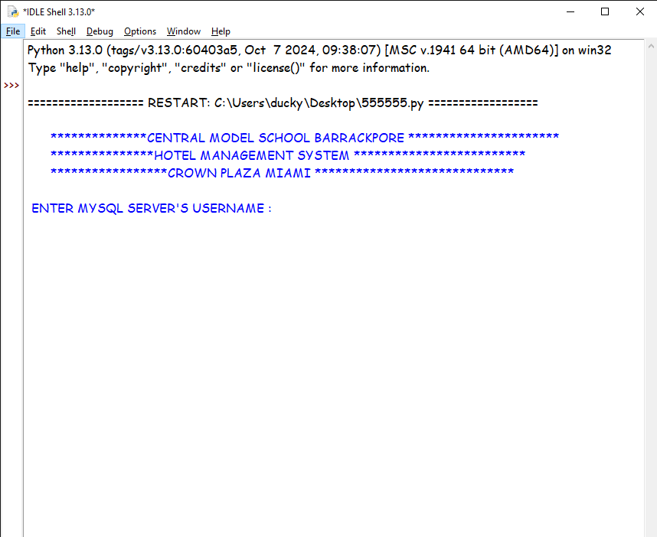
Program Output
Main Screen

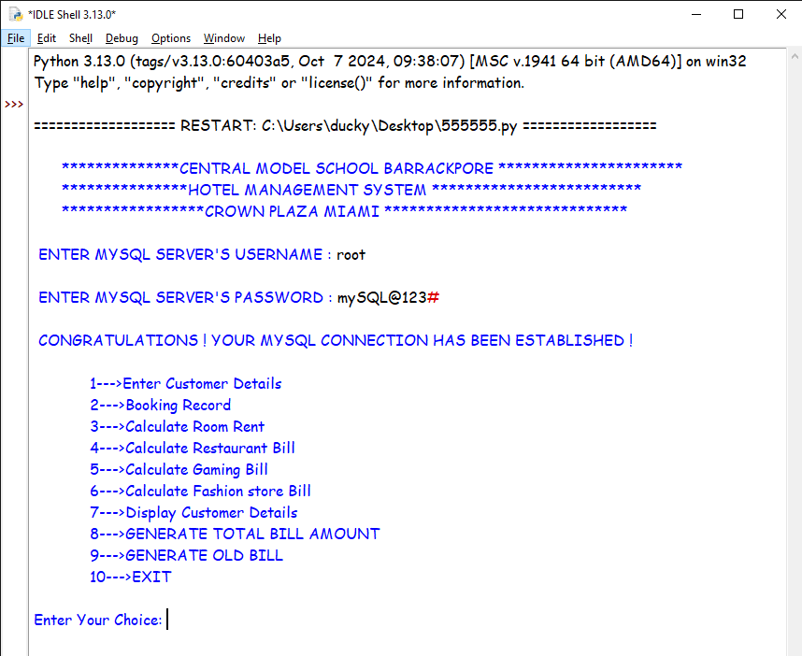
User Authentication
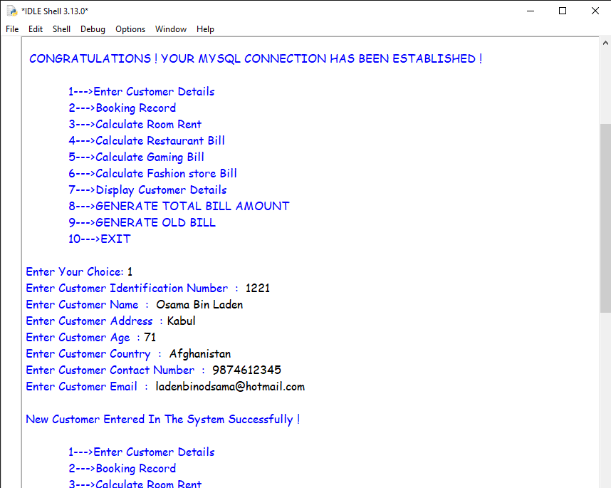
Customer Details
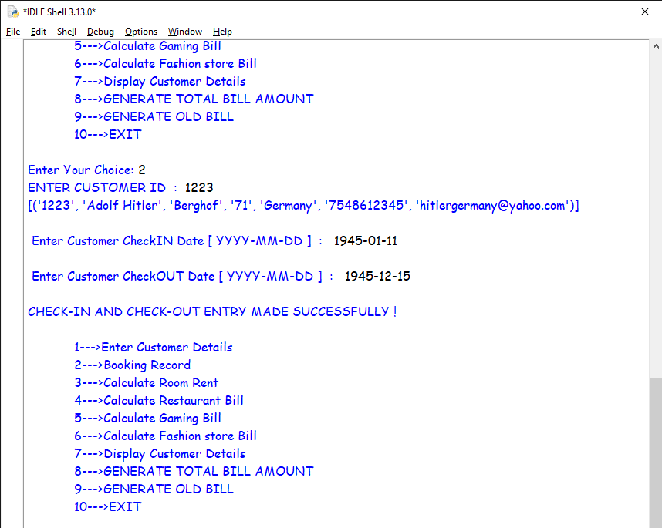
Customer Booking Records
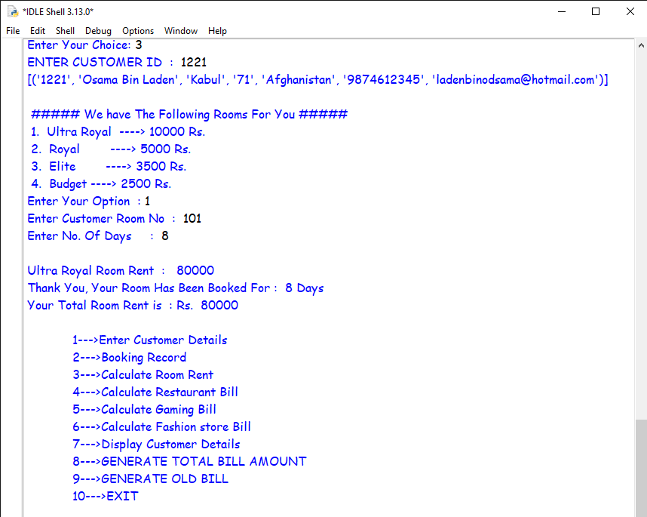
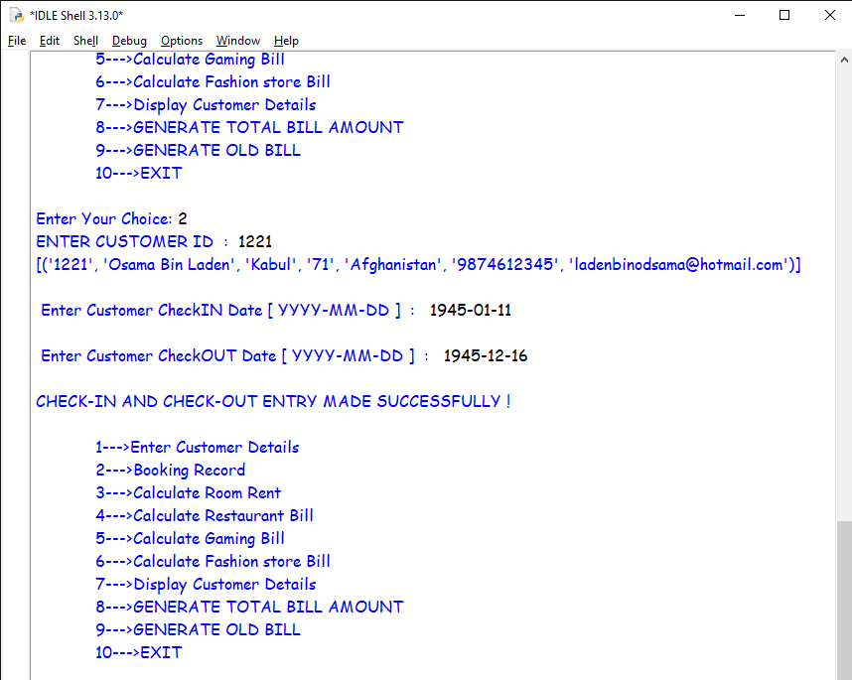
Room Rent
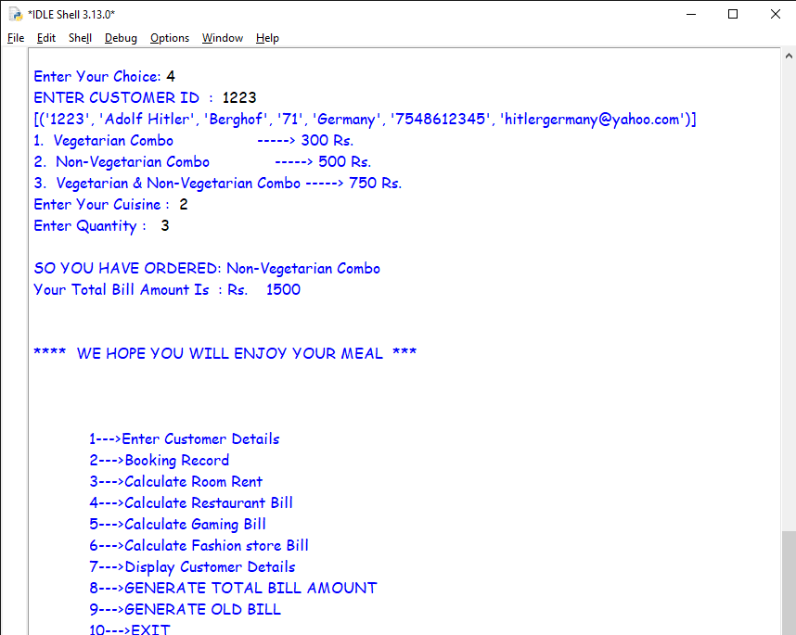
Gaming Bill
Restaurant Bill
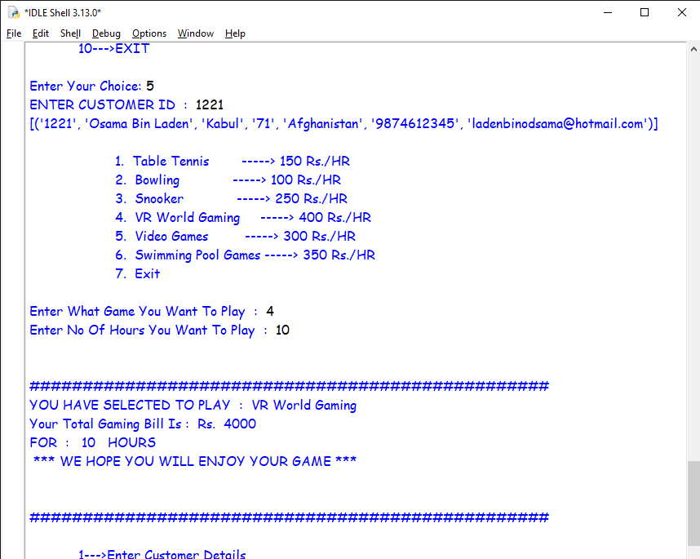
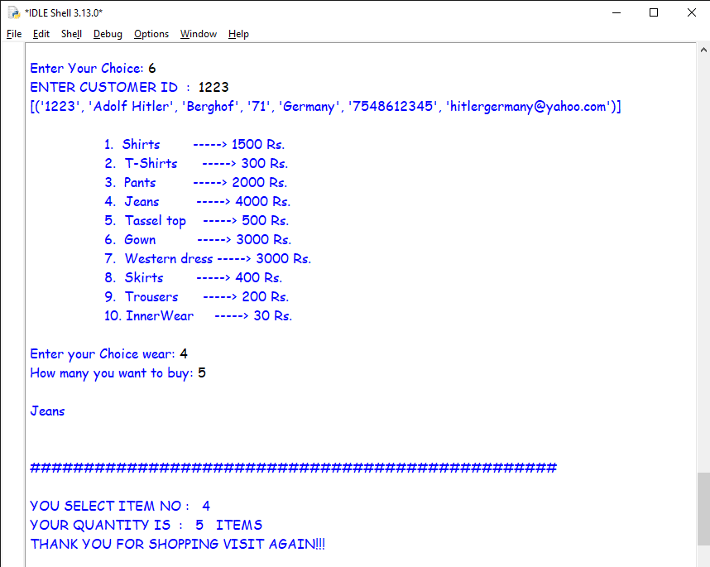
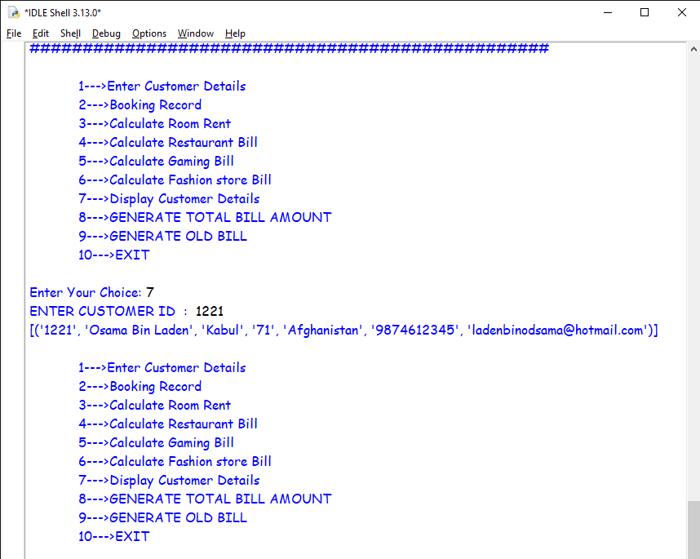
Details Of Customer
Fashion Bill
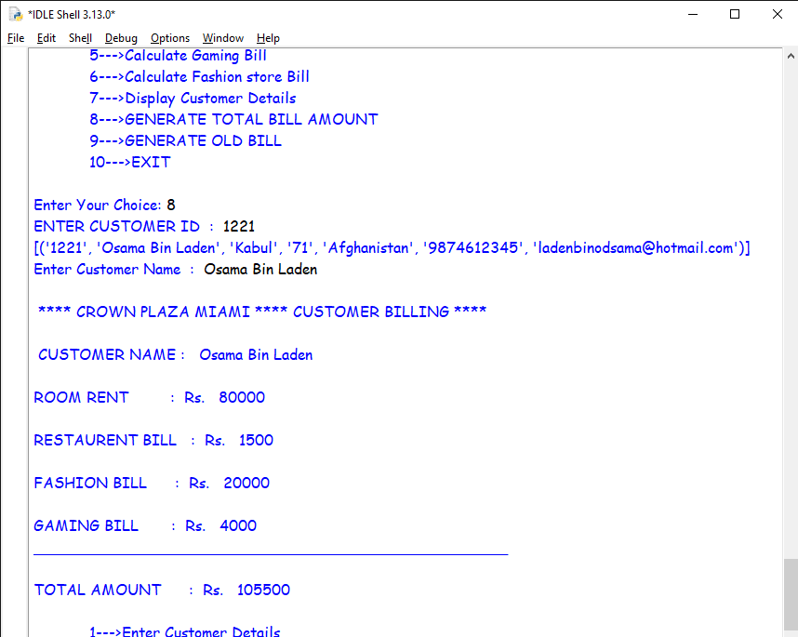

Total Bill
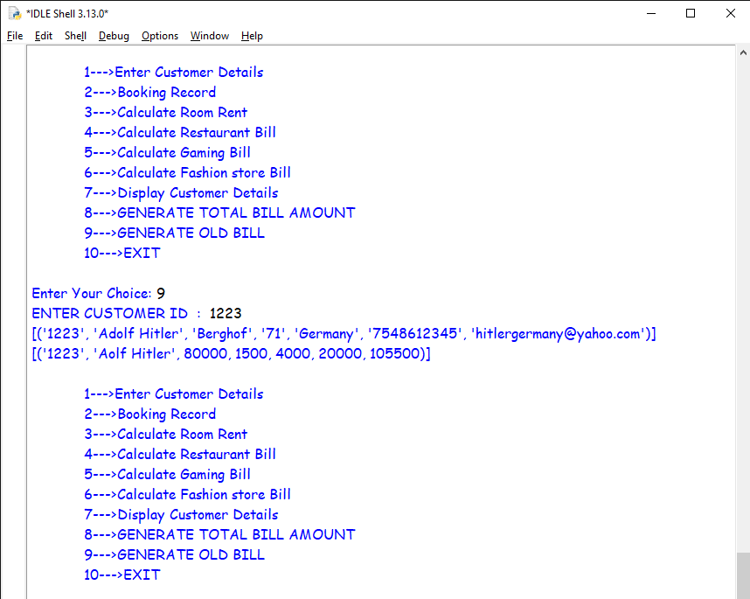
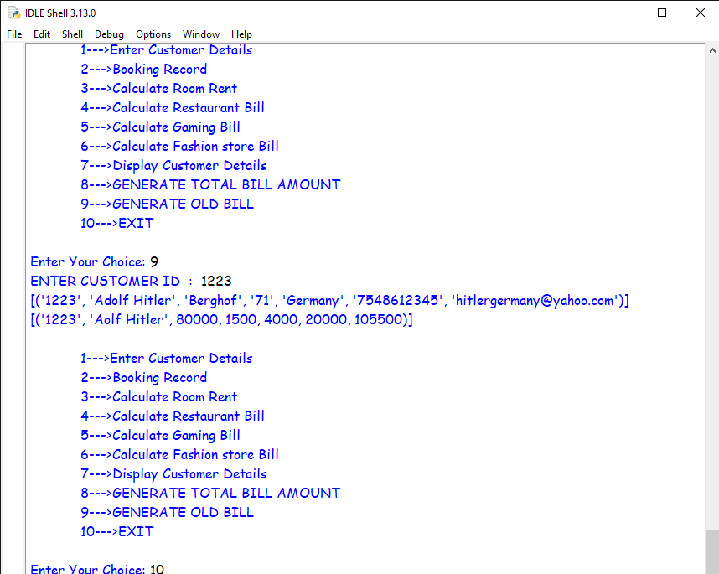
Exit
Old Bill
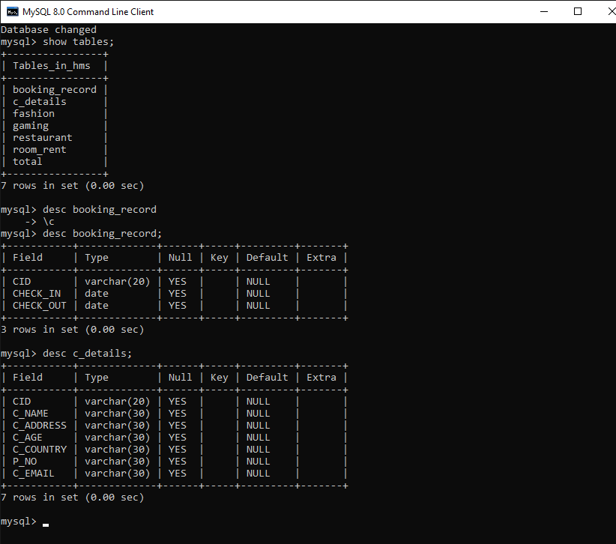
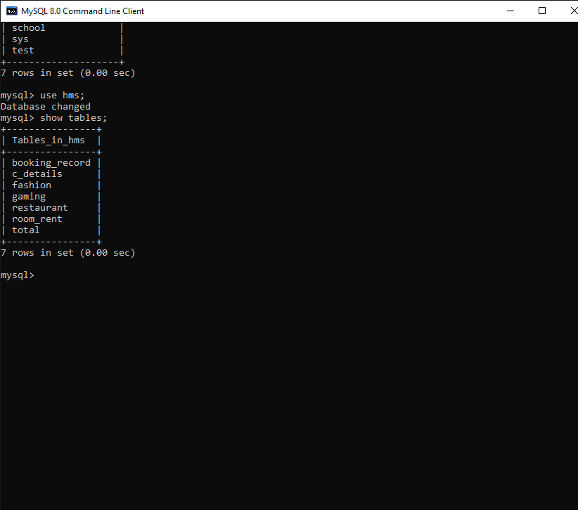
Table Structure 1 & 2
MYSQL Database
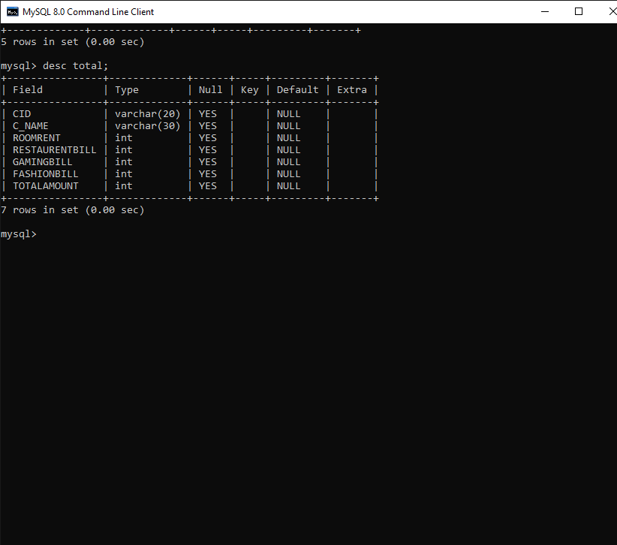
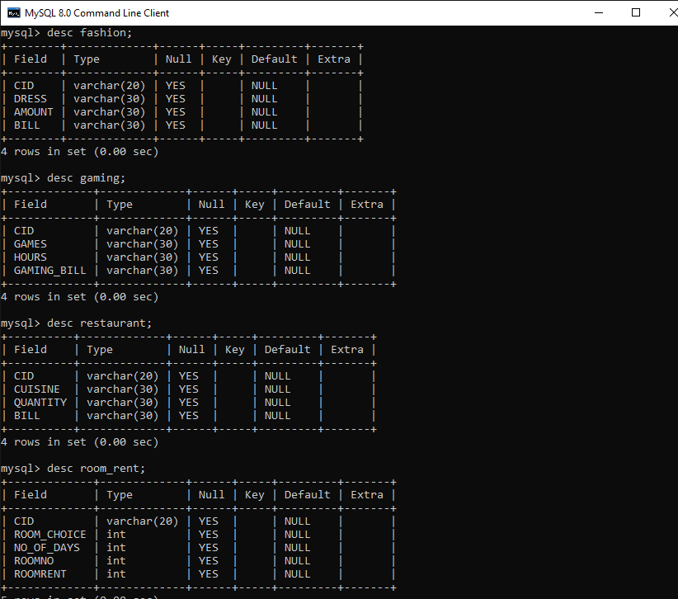
Table Structure 7
Table Structure 3,4,5 & 6
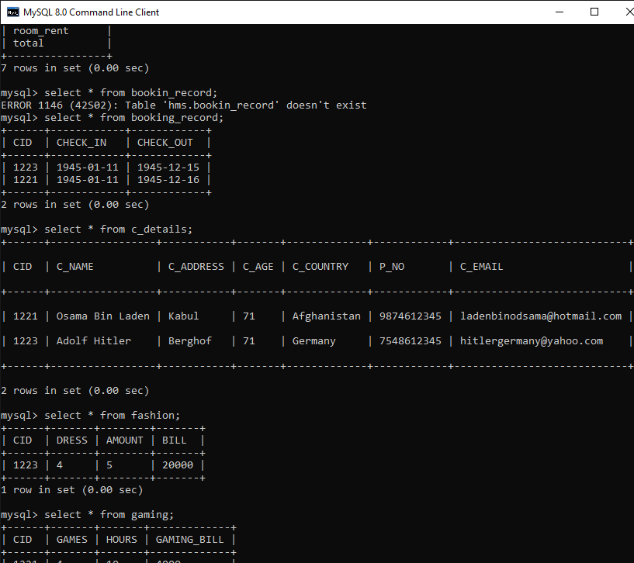
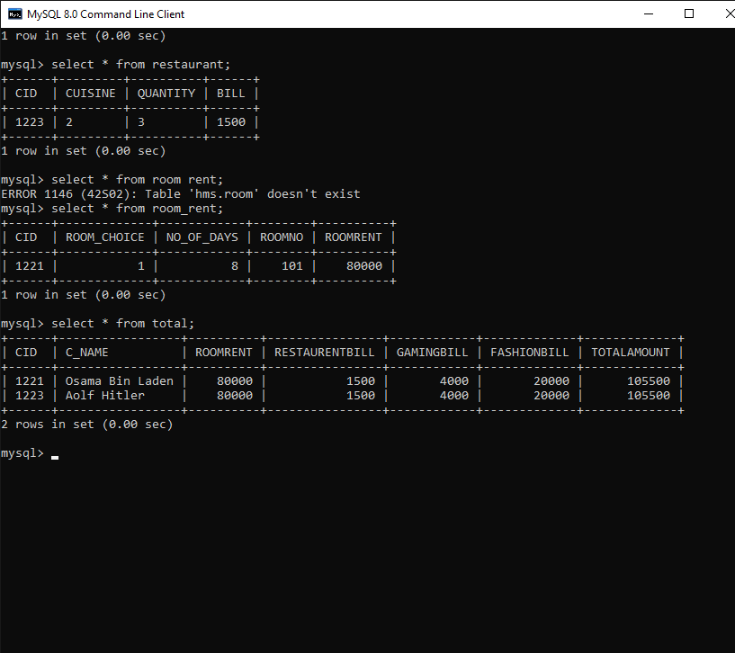
Data Created through MYSQL

BIBLIOGRAPHY

Sites:
- www.google.com
- www.geekforgeeks.org
- www.python.org
- www.mysql.org
- www.github.org

Books:
- Computer Science with Python for Class XII by Sumita Arora
- NCERT Computer Science Class XII

